In order to handle a vessel efficiently, during cargo operations, the following pre arrival questionnaire must be submitted by email prior to arrival to Vopak Terminal Vlaardingen.
We kindly ask you to fill in chapter 1-8, (incl. 6 part 1A/1B) and send this document to:
E-mail: isgott6.vlaardingen.nl@vopak.com
List of contents 9 pages:
- Ship’s particulars. page 1
- General questions about cargo. page 1
- Questions about the loading or discharge, and hazardous cargo on board. page 1
- Plan for prewash. page 2
- Process flow chart about the prewash procedure. page 3
- ISGOTT 6 part 1A, 1B & part 2 page 4
- Frequently asked questions about the rules of the terminal. page 5
- Minimum mooring requirements. page 6
- Mooring layouts of all the berths. page 6
- Terminal overview photo. page 9

Information required before berthing, please fill in the questions.

- Ship’s particulars.
- Vessel’s name & call sign : Klik hier als u tekst wilt invoeren.
- I.M.O. registration number : Klik hier als u tekst wilt invoeren.
- NOR tendered : Klik hier als u tekst wilt invoeren.
- ETA of vessel : Klik hier als u tekst wilt invoeren.
- Owner : Klik hier als u tekst wilt invoeren.
- Flag : Klik hier als u tekst wilt invoeren.
- LOA in meters : Klik hier als u tekst wilt invoeren.
- Beam in meters : Klik hier als u tekst wilt invoeren.
- Gross Tonnage : Klik hier als u tekst wilt invoeren.
- Deadweight (DWAT) : Klik hier als u tekst wilt invoeren.
- Bow Centre Manifold in mtr : Klik hier als u tekst wilt invoeren.
- Manifold connection size : Klik hier als u tekst wilt invoeren.
- General questions about cargo.
- Previous cargo in loading tanks that are going to be used: Klik hier als u tekst wilt invoeren.
- Are loading tanks gas free and free of smell/stench: yes / no Klik hier als u tekst wilt invoeren.

- Questions about the loading or discharge and hazardous cargo on board
- What is the product(s) to be loaded / discharged : Klik hier als u tekst wilt invoeren.
A cargo breakdown including complete stowage plan has to be send to the agent / terminal in advance.
- Quantity to be loaded or discharged (in mton & m³): Klik hier als u tekst wilt invoeren.

- Max loading/discharge rate (in m3/hr) vessel can accept / give: Klik hier als u tekst wilt invoeren.

- Draft upon arrival and or after loading / discharge (in meters): Klik hier als u tekst wilt invoeren.

- Reducers on board, please specify in an overview ANSI or DIN and amount and size: Klik hier als u tekst wilt invoeren.

- Are there any chemicals on board or in transit with flash point <55 degrees Celsius?: Klik hier als u tekst wilt invoeren.
- If yes, please advise which product and stowage on board: Klik hier als u tekst wilt invoeren.
- Are these tanks full or empty?: Klik hier als u tekst wilt invoeren.

- Are there any chemicals in wash water on board (slob tanks) or in transit with flash point <55 degrees Celsius?: Klik hier als u tekst wilt invoeren.
- If yes, please advise which product and stowage on board: Klik hier als u tekst wilt invoeren.

- Plan for prewash.
Prior to arrival of the vessel you must inform Vopak Vlaardingen of the prewash activities.
Please communicate the schedule with the agent and terminal and specify whether:
  - Prewashing activities will be carried out on our berth or somewhere else ? Klik hier als u tekst wilt invoeren.
  - Collection of the prewash will be executed on our berth or somewhere else? Klik hier als u tekst wilt invoeren.
  - You are going to prewash and confirm you will finish the prewash activities within the time of discharging/loading of your cargo ? Klik hier als u tekst wilt invoeren.
- between and during the discharge of the products ?: Klik hier als u tekst wilt invoeren.
- or after the discharge/loading of all products ?: Klik hier als u tekst wilt invoeren.
  - Do you want to tranship the prewash to a collection barge before or after cargo completion? (when present on our berth): Klik hier als u tekst wilt invoeren.

**Remarks**
- After cargo completion, if the entire prewash operation takes longer than 4 hours (this includes time for ordering pilot), Vopak Vlaardingen will not give permission to exceed this 4 hours. The vessel must leave our berth.
- Vopak Vlaardingen only gives permission for pre wash activities under conditions mentioned in the below process-flow chart and prior to arrival.

- Process flow chart about the prewash procedure.

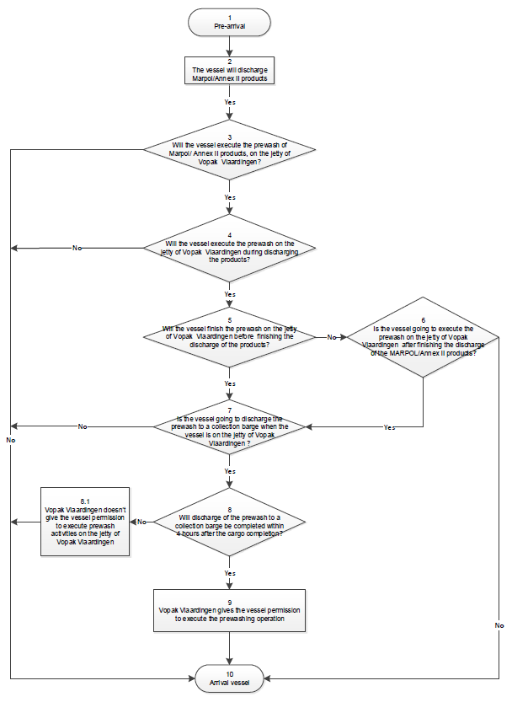

- ISGOTT 6, part 1A & part 2

Pre arrival checks part 1 A tanker and Part 2 Terminal based on ISGOTT 6 ship/shore checklist
The new ISGOTT 6 ship/shore checklist has a new pre-arrival checklist for ship and Terminal

Part 1 A Tanker : checks pre-arrival

Part 1A. Tanker: checks pre-arrival
Item | Check | Status | Remarks
1 | Pre-arrival information is exchanged (6.5.21.2) | ☐ Yes
2 | International shore fire connection is available (5.5, 19.4.3.1) | ☐ Yes
3 | Transfer hoses are of suitable construction (18.2) | ☐ Yes
4 | Terminal information booklet reviewed (15.2.2) | ☐ Yes
5 | Pre-berthing information is exchanged (21.3, 22.3) | ☐ Yes
6 | Pressure/Vacuum valves and/or high velocity vents are operational (11.1.8) | ☐ Yes
7 | Fixed and portable oxygen analysers are operational (2.4) | ☐ Yes

Part 1B. Tanker: checks pre-arrival if using an inert gas system
Item | Check | Status | Remarks
8 | Inert gas system pressure and oxygen recorders are  operational (11.1.5.2, 11.1.11) | ☐ Yes
9 | Inert gas system and associated equipment are  operational (11.1.5.2, 11.1.11) | ☐ Yes
10 | Cargo tank atmospheres’ oxygen content is less than  8% (11.1.3) | ☐ Yes
11 | Cargo tank atmospheres are at positive pressure  (11.1.3) | ☐ Yes

Part 2 Terminal : checks pre-arrival

Part 2. Terminal: checks pre-arrival
Item | Check | Status | Remarks
12 | Pre-arrival information is exchanged (6.5.21.2) | ☒ Yes | Terminal Booklet info, pre-arrival document is sent to ship by agent.
13 | International shore fire connection is available (5.5, 19.4.3.1, 19.4.3.5) | ☒ Yes | Connection and hoses are present on 624, 626 and 628 in orange jetty box.
14 | Transfer equipment is of suitable construction (18.1, 18.2) | ☒ Yes | Equipment is in good and safe condition.
15 | Terminal information booklet transmitted to tanker (15.2.2) | ☒ Yes | Terminal booklet is sent to ship by agent
16 | Pre-berthing information is exchanged (21.3, 22.3) | ☒ Yes | Pre-arrival document is sent to ship by agent
By sending Part 2 Terminal in this questionnaire and the request to send back part 1A & 1B, the Ship and the Terminal agree to the pre arrival checks. After mooring and during safety conference on board the pre arrival checks will be formally registered in the ISGOTT 6 checklist.

- Frequently asked questions (FAQ) about the rules of the terminal.
At Vopak Terminal Vlaardingen the following rules apply:
- All jetties are equipped with 6 inch DIN flexible hoses fitted with bolts and nuts.
- The loading master of Vopak Vlaardingen, together with the ship’s captain, will only fill in the ship shore checklist of Vopak. This is valid according to ISGOTT/ISM.
- Reducers between sizes 10 inch DIN and 6 inch DIN can be provided by Vopak Terminal Vlaardingen. The reducer has to be mounted by the ship’s crew.
- Bunkering is only allowed on our jetties 624, 626, 628 and 634 during loading/discharge activities.
For berth 621 a special request for bunkering has to be made via the planning department, prior to arrival (because of the available barge space alongside).
- The maximum backpressure on the line depends on the jetty, shoreline and tank group where to discharged. Max 6 bar or 8 bar (the loading master will agree and document this on arrival).
- Loading from shore tank only with shore stop.
- Dead ship: we are allowed to load or discharge dead ships, provided that the agent requests permission from the port authorities in advance and informs Vopak Vlaardingen by mail.
- Lines will be emptied after loading by pigging, blowing with air, nitrogen or steam, depending of type of product.
- All stores have to be supplied by barge.
- Fresh water has to be delivered by barge.
- Tank cleaning alongside the berth is allowed, if executed in closed system.
The request has to be submitted to the port authorities. (for prewash, see chapter 4 questions)
- The terminal has no vapor return line and unit.
- During board to board transhipments vapor return hoses are required for hazardous cargo’s according to Port Authority’s manual, and particularly for Vopak Vlaardingen also for smelly (stench) products. Vopak will also provide a grounding cable if necessary, between the two vessels.
- In case the vessel must connect flexible hoses to the pump stack, Vopak terminal Vlaardingen demands the following, in order to guarantee the safety of the environment, crew on board and our operators:
- Flexible hoses (including gaskets, bolts and nuts), arranged via the agent/ship, must be delivered upon arrival.
- The flexible hoses must be connected to the pump stack with a valve (for safety reasons).
- Connections to the pump stack have to be made by the ship's crew.
- If the vessel does not meet up to these safety requirements, Vopak Vlaardingen will not start the loading/discharge process.

- Minimum mooring requirements.

Deadweight | Required mooring retention | Mooring lay-out
 |  | Head and stern lines | Spring lines | Breast lines
<5.100 mton | 120 – 180 KN | 2 | 2
>5.100 - <10.000 mton | 280 – 350 KN | 3 | 2
 |  | 2 | 2 | 1
>10.000 - <17.000 mton | 350 – 400 KN | 2 | 2 | 2
 |  | 4 | 2
>17.000 mton | 400 – 600 KN | 3 | 2 | 2

The vessel’s Master hereby declares that the above information is correct and fully understood.

Master’s name : Klik hier als u tekst wilt invoeren. Date: Klik hier als u een datum wilt invoeren.
Signature or stamp:

- Mooring layouts of all the berths.

BERTH 621

GENERAL MOORING LAYOUTS – Preferably Starboard – depending on tide

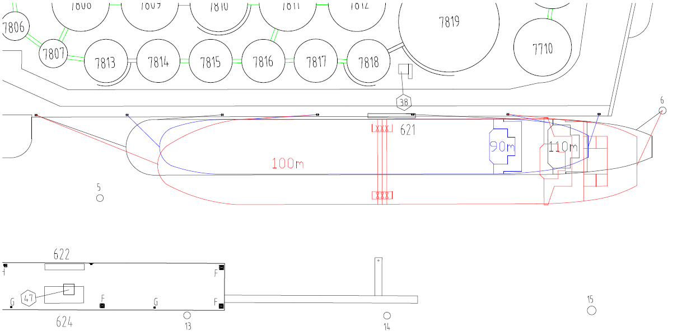

BERTH 624

- GENERAL MOORING LAYOUTS (several dimensions)
- Starboard for LOA 120 mtr and smaller,
- Portside for LOA 121 mtr and longer.

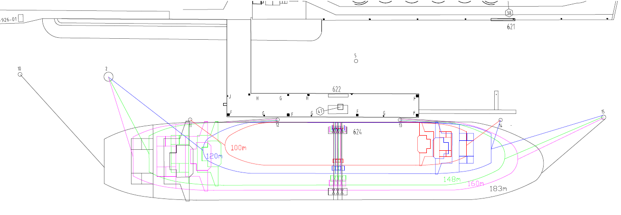

BERTH 626

GENERAL MOORING LAYOUTS– Preferably Starboard

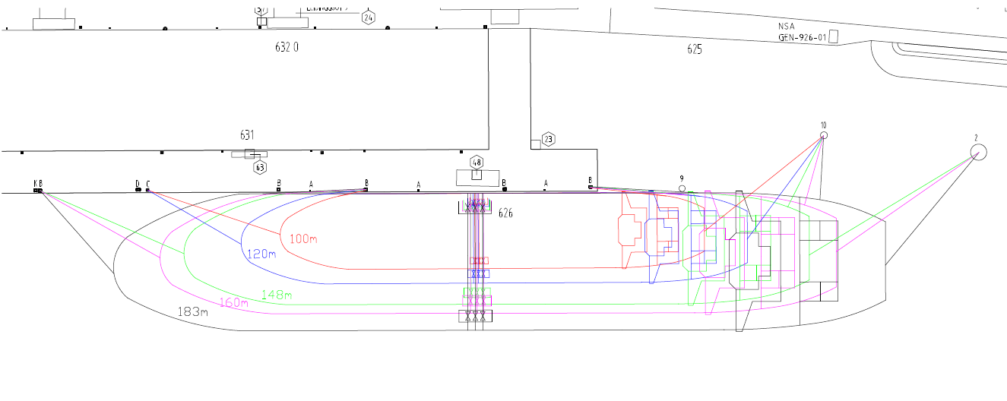

BERTH 628

GENERAL MOORING LAYOUTS– Portside

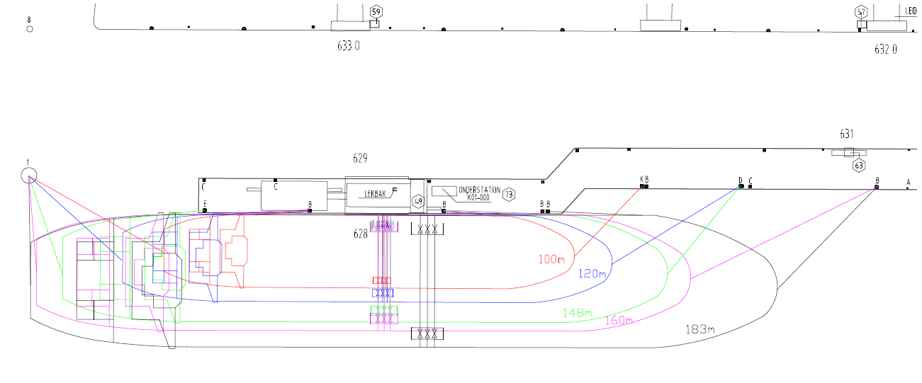

BERTH 628 & 626
GENERAL MOORING LAYOUTS For two ships berth 628 & 626 in line

Vessel 183 m moored at berth 628 and Vessel 144 m moored at berth 626
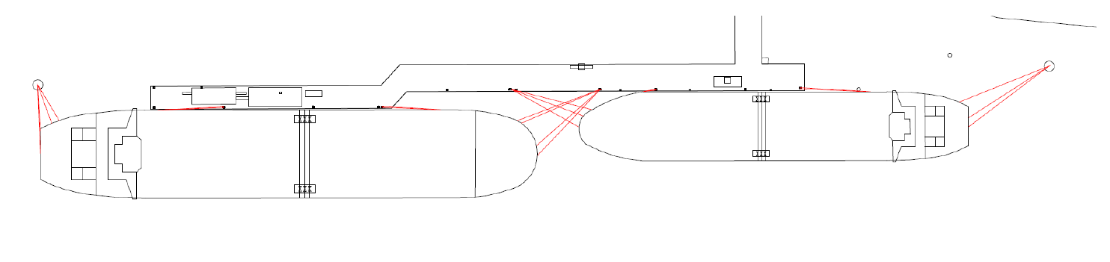
Berth 626
Berth 628
183 m
144 m
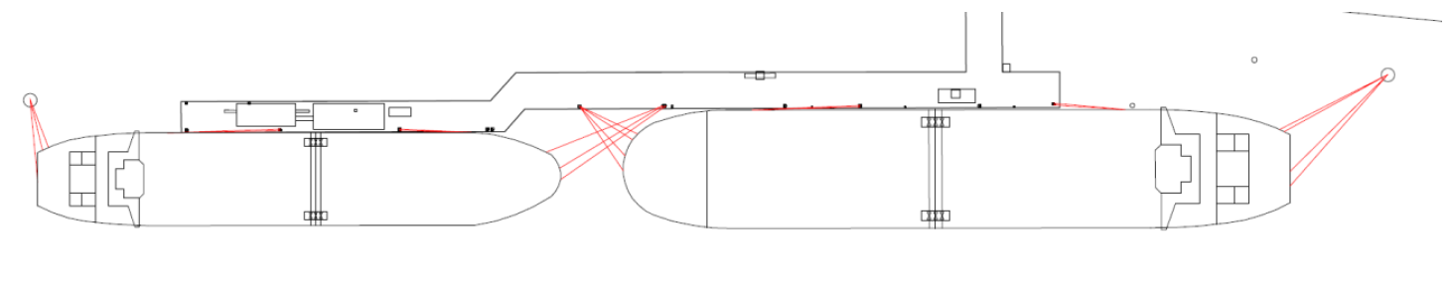
Vessel 144 m moored at berth 628 and Vessel 183 m moored at berth 626
183 m
144 m
Berth 626
Berth 628
BERTH 634
GENERAL MOORING LAYOUTS– Preferably Starboard
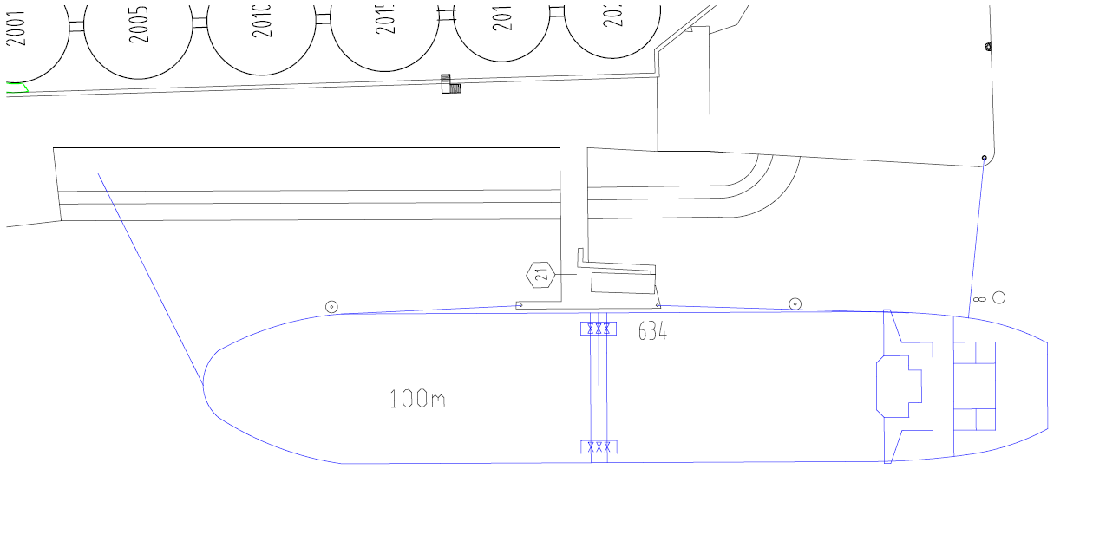

- Terminal overview photo.
